Celebrate Mission & Service
OCTOBER
IS
STEWARDSHIP MONTH
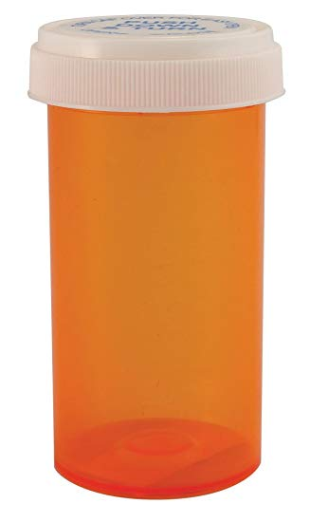

Encourage your congregation to be creative by filling a pill bottle. They can hold between 25 to 40 toonies. (Bills can also fit in those pill bottles)
ALL PROCEEDS WILL GO TO
FOOD FOR THE NORTH

Return your toonies anytime from
now until November 3, 2019 to your Church Treasurer

Reminder: Don’t forget to attach a sticky personal address label with your name and envelope/ PAR number so your donation is recognized and counts towards your annual givings.
Thank You for Participating.

For more information contact
Marilyn Rodger
at marilynrodger@aol.com

