**COVID Communications and Programming Grant**

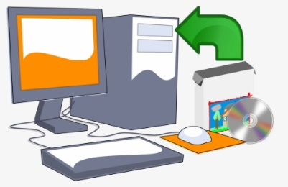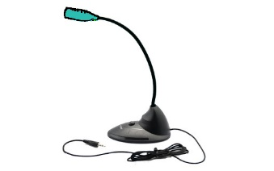Enhance the work of your faith community

***These are just a few examples of how a grant could assist you in your ministry.***

Applications, for up to $5000.00, can be submitted until October 15th, 2020

The Application can be found at https://ecorcuccan.ca/covid-grant/

**ACCESSIBILITY**

- tablets to share with

church members

-shared WIFI access

**PURCHASES**

- improved resources

at church

- communication programs

**TRAINING**

- in usage of technology for meetings or church services.

- for members

on the use of ZOOM,

or other programs.