Thanks to ECORC’s Doing Mission Together & M&S grants in 2020
Bedford House Community Ministry is growing new Communities of Faith.
January 2021

A prophet once wrote “Don’t it always seem to go – that you don’t know what you’ve got til it’s gone?”.

The past year has proven this true in so many ways. Trips to foreign locales, restaurants, theatre, and trips to the mall – are all gone. Kind of makes one appreciate what we’ve lost eh?

Except if you’re living below the poverty line. Many of those items that folks with disposable income take for granted were never enjoyed.

The song continues “They paved paradise and put up a parking lot!”. So, let’s ask “what was beneath that parking lot?” What exactly was the paradise lost? What has the colonization and consumerization of our lives paved over in these past decades?
Defining “Faith”
Faith as an individual experience of that which kindles a flame in the human heart. We welcome all expressions of what each community member perceives and trusts as their own deepest experience.

We make room for each community member to continually discover their life’s purpose and how their unique gifts might contribute to the health and wellbeing of us all.

In Bridging Teams we share a faith in the “end story” of a network of people sharing resources, opportunities, and - most importantly - stories, food, fun, and learning!
Bridges Peterborough, a project of Greenwood United Church and Bedford House Community Ministry, invites participants to explore the ever-widening gap between privilege and poverty in our communities.

In the midst of that gap, folks from all walks of life discover the heart of what a “faith community” is - the paradise beneath the pavement.

We are discovering Faith without religious doctrine and a Community without barriers to participation. We create safe spaces to share stories, laugh, ask good questions and learn to listen well. In such spaces, a weekly “bridging team” gathers and the magic happens.”

In February a new team will begin the year-long process of bridging poverty and privilege. Ten “well-resourced” mentors and five “under-resourced” catalysts, led by trained facilitators will follow a process mapped out over the last five years.

The team will be led by Ralph and Laura, two recent graduates of Bedford House’s Facilitator training program. Both are also alumni of past Bridging Teams.

Ralph, retired after a career in teaching mediation and law, has walked on both sides of the bridge. “When I first was invited to join the team, I wasn’t too sure. I thought I’d attend a few sessions and see what it had to offer.” That was over three years ago.

Laura’s laughter is contagious. The joy and wisdom she shares has been earned through decades of battling her way through abuse, addiction, and cancer. “This is the best thing that’s ever happened to me.” she explains as her motivation for creating a new team.

Laura and Ralph are two of six members of the Company of Conversation Changers – a social enterprise they’re starting to educate, animate, and facilitate community change. Here’s the invitation drafted by the Company of Conversation Changers;

Would you like to be a part of something powerful and impact social change in 2021?

What if you joined a small group that meets weekly to have fun crossing socio-economic lines - with people you might not otherwise meet - to explore the “hidden rules of class” that we each follow? (www.bridgespeterborough.ca)

What if we changed the conversation around poverty and privilege by supporting each other, sharing joy and creating space for the magic to happen - the magic that happens when people from different walks of life find common ground.

Then joining a Bridging Team might be for you…

The Bridging Team model is based on the lived experience of Lynn Smith-Reeve as she invited a circle of mentors to support her own seven-year journey from poverty to commissioning as a Diaconal Minister. She now trains new Bridging Team facilitators and offers workshops on the Bridges Out Of Poverty educational framework that Bridges Peterborough uses.
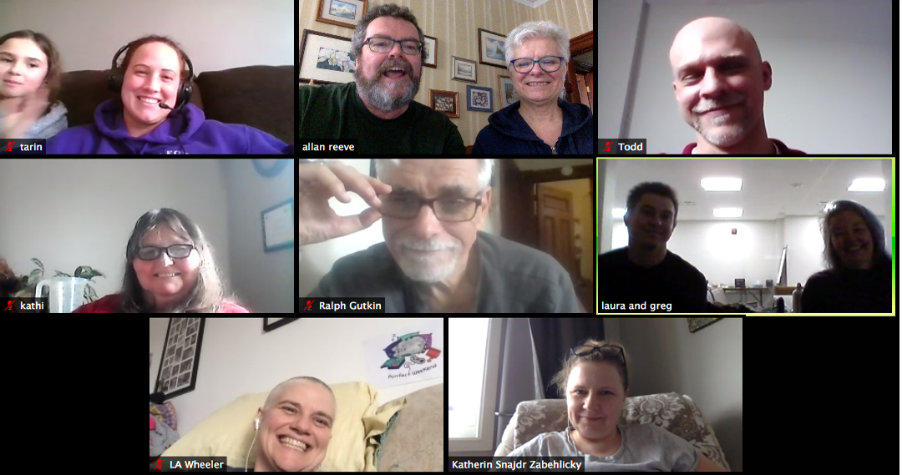
From top left: Fleming college student Tarin Atwood & daughter, Bedford House Reverends Lynn & Allan Smith-Reeve, Company of Conversation Changer members: Todd Coombes, Kathi Curtin-Williams, Ralph Gutkin, Greg Parnall & Laura Warren, L.A. Wheeler, and Bridges Peterborough Program Manager Kat Snajdr-Zabehlicky.

To learn more about how your church might either support or start a Bridging Team visit www.BridgesPeterborough.ca

We’d love to share our story and explore with you how a Bridging Team might grow in your midst. Contact: Reverend Lynn Smith-Reeve at lynn@bridgespeterborough.ca
