Guaranteed Livable Income and Health
In his earthly ministry Jesus was deeply concerned with the wellbeing of the whole person. Again and again in his encounters with the marginalized of society he acted to restore their hearts, minds, souls, and bodies. As a church we can continue to follow in Christ’s healing footsteps by advocating for the introduction of a Guaranteed Livable Income in Canada. From the research of individuals like Dr. Evelyn Forget who was recently appointed as an officer of the Order of Canada , we know that: “﻿Basic income recipients are less likely to need to be hospitalized compared with similar individuals who do not receive a basic income.”*
As we pray for the health of friends and strangers alike, let’s pray too for the introduction of a Guaranteed Livable Income in Canada, and support the movement for GLI.

* Basic Income for Canadians: From the COVID-19 Emergency to Financial Security for All, Dr. Evelyn Forget, 2020
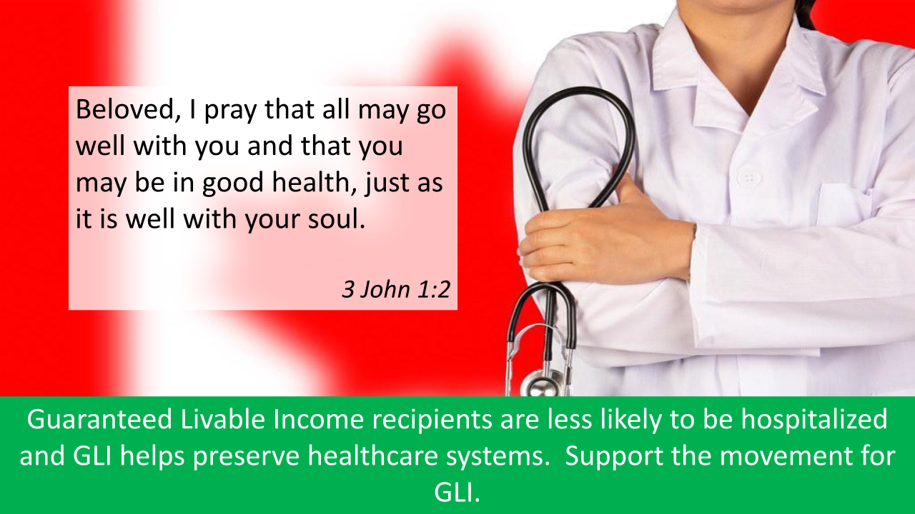

Guaranteed Livable Income and Racialized Communities
Key leaders in the early Christian church envisioned a world where the divide between people of different ethnic backgrounds would be bridged by Christ’s love. Sadly, still today in Canada, we know that “Systemic racial . . . discrimination [has] resulted in higher rates and a persistence of poverty among . . . racialized Canadians [and] Indigenous Peoples.”*. Adopting a Guaranteed Livable Income program is an important step in restoring the early church’s vision for a world where all peoples have access to the resources they need to live with dignity as beloved children of God.
As we pray for the work of equity and justice in our world, let’s pray too for the introduction of a Guaranteed Livable Income in Canada, and support the movement for GLI.
* Basic Income: Rethinking Social Policy, Alex Himelfarb and Trish Hennessy, editors, 2016
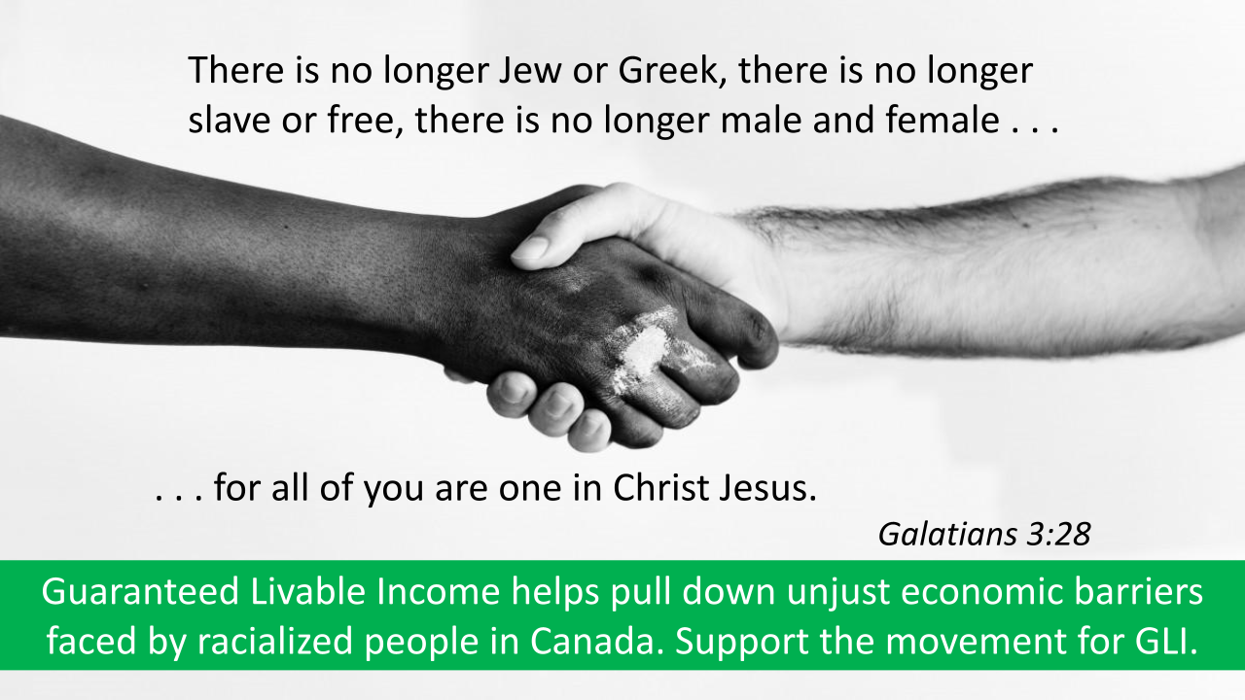
Guaranteed Livable Income Supports Workers Displaced by Technology
Ecclesiastes knows that years of honest hard work and doing your best is no guarantee that you won’t be tossed aside.
According to a study by the Brookfield Institute for Innovation and Entrepreneurship *, close to 42 percent of the employed Canadian labour force is at a high risk of being affected by automation over the next 10 to 20 years.
Just think of the recent proliferation of self-serve checkouts at the grocery store! Along with cashiers, retail salespersons, administrative assistants, and food counter and kitchen workers are the occupations more than 90% likely to feel the impact of automation in Canada
If robotics and machine learning are going to take many existing jobs and make it hard for people without advanced technical skills to find work, there is a looming crisis for society as a whole. There is a potential for large numbers of people ( 1.5 million from the occupations above alone) to be left behind creating an underclass of the permanently unemployed.
Guaranteed Livable Income gives support to people who find that their jobs have been eliminated by technology. It can help lift the financial stress and personal demoralization that comes with being replaced by a robot as they transition to something else- go back to school, retrain for another field, explore entrepreneurship, etc.
GLI a humane response to the technological revolution. Support the movement for Guaranteed Livable Income.
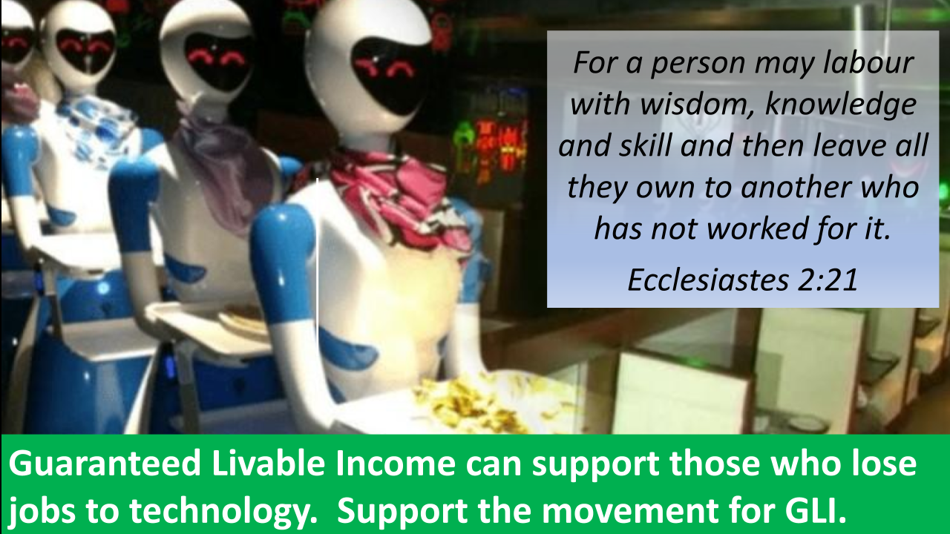

Guaranteed Livable Income Unleashes Human Potential
Jesus wants us to experience fullness of life, and he came to show us what fullness of life looks like. But in order to reach for something more, we must first ensure that we have a foundation of human dignity securely under our feet. With Guaranteed Livable Income, people don’t have to spend time, money and energy meeting basic needs like food and rent- instead they are freed to expand their personal horizons and their contributions to their local community.
They can start a business, volunteer time in their neighbourhood, upgrade their education, pursue an artistic calling, or provide care to a vulnerable loved one. By ensuring their basic dignity, and by giving them the gift of time to try something else, Guaranteed Livable Income frees people to pursue fullness of life on their own terms. GLI gives people the power to make decisions based on their own circumstances and choices, not based on those prescribed by a government program, a well-meaning bureaucrat or the priorities of an employer.
Jesus was a great believer in human potential, after all he said “the kingdom of God is within you.”
GLI is an investment in growing the kingdom and encouraging its gardeners.
Support the movement for Guaranteed Livable Income.
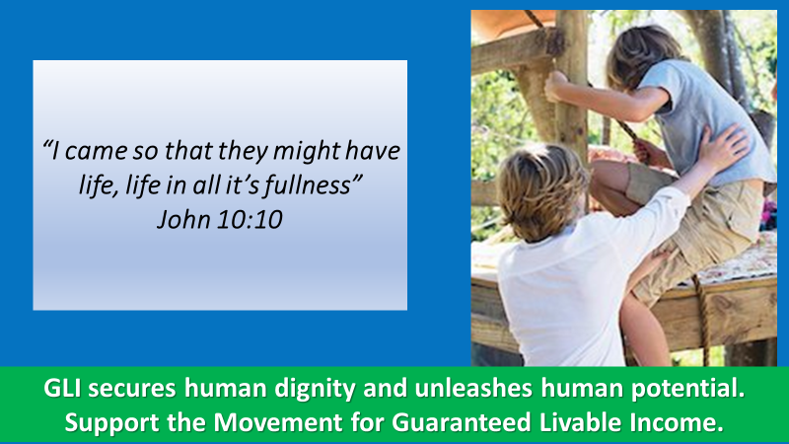

Guaranteed Livable Income Does Not Cause Inflation.
Proverbs urges us to speak out and defend the rights of the poor and needy. In the case of Guaranteed Livable Income this includes countering some of the myths surrounding GLI. One of these is that a Guaranteed Livable Income causes people to stop working. In every pilot project and experiment with GLI, including the Manitoba Mincome experiment of the 1970s the data shows that this is simply not the case.
Another myth around Guaranteed Livable Income is that giving people more money will automatically lead to a higher rate of inflation- everything will cost more and this will erode any potential benefit.
But studies of cash transfer programs in Mexico, Lebanon, and seven different countries in Sub-Saharan Africa show that this is not true either. In Kuwait inflation actually went down during a Basic Income pilot project, and the rate of inflation in the state of Alaska has been lower than the American national average since the state introduced the Permanent Financial Dividend in 1982. * That’s a consistently lower rate of inflation in Alaska for 40 years!
In the face of negative myths, the movement for Guaranteed Livable Income speaks positive truths such as GLI will lift millions of people, over fifty percent of whom are the working poor, out of poverty.
What is true is that a Guaranteed Livable income allows people to meet their basic needs, regardless of their employment status, and empowers them to make their own choices about how they spend money.
GLI defends the right of all people to live in dignity.
Support the movement for Guaranteed Livable Income.
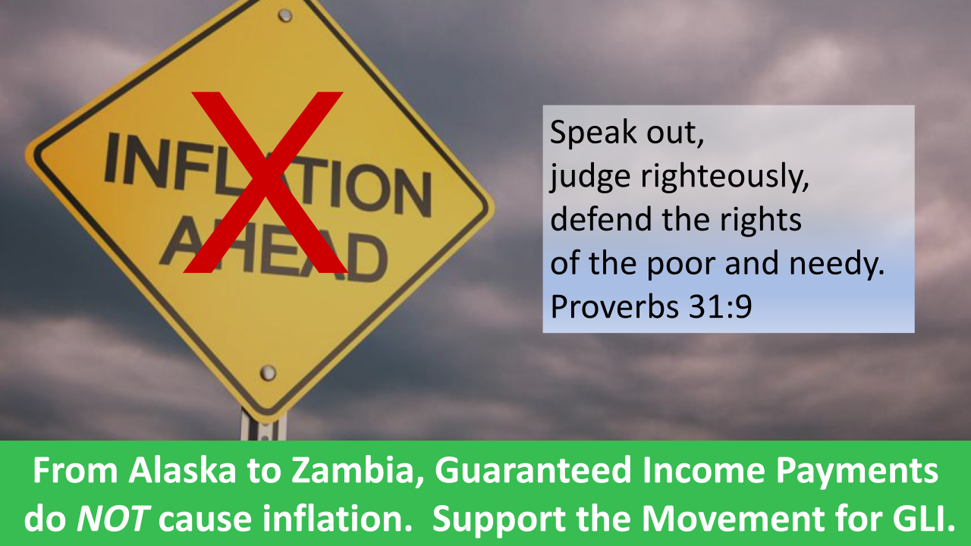

Guaranteed Livable Income Ends the Stigma of the Undeserving Poor
The disciples want the hungry crowds to help themselves. These people chose to follow Jesus into the wilderness without packing a lunch. It was their own fault for not thinking ahead, their responsibility for not looking after their resources, let them deal with the consequences of their poor choices.
Jesus does not bother to defend the crowd’s judgement or their actions. Jesus is focused on their need and on the disciple’s willingness to provide for that need.
Jesus’ concern is that the crowds of men, women and children are hungry, he is not concerned with judging who does and does not deserve to be fed. Significantly, Jesus also has faith that the disciples have or can find the means to meet the needs that have been presented.
A program of resource distribution is organized, the available food is shared and all in the crowd are fed. No questions are asked, no forms are filled out, no medical reports, drug tests, or records of employment or character witnesses are required.
Because Guaranteed Livable Income establishes a decent, modest amount of income below which no one is allowed to fall, because it is based on one’s need and not on a judgement of one’s worth, GLI eliminates the social stigma that comes with being seen as the undeserving poor.
GLI can be a building block of God’s kingdom.
Support the movement for Guaranteed Livable Income.
