**MAPPING THE GROUND WE STAND ON**

As an action in learning truth for reconciliation,

**The MS and Outreach Committee of**

Centennial Albert UC, **Eastern Central Ontario Regional Council**

is hosting anin-person workshop on

**Sunday February 11th, 2024, 12:30 to 3:30 including a break,**

optional lunch 11:45-12:15 & room for lunch

**facilitated by Cheryl Marek, volunteer PWRDF workshop facilitator**

**Please register by 11:59 PM of Feb. 3rd, by sending the registration for to cent.albert.uc@gmail.com:**



• Consider if a friend or family member, 14 years and older, might also register.

• After you register, preparation steps will be sent by the facilitators 5-7 days before the event.

Post-event resources will be sent.

For more information, please contact Centennial Albert UC, 905 725-8621.

*In 2015, as part of its commitment to support the findings of the Truth and Reconciliation Commission, PWRDF developed the resource: Mapping the Ground We Stand On. Using PowerPoint animation, videos, small group discussion, talking circle and more this workshop, also known as the Mapping Exercise, invites participants to explore Indigenous presence on the map of Turtle Island/Canada, the history of settler arrival, and how each fit into ongoing narratives. The concepts of Doctrine of Discovery, terra nullius, Indigenous Knowledge and Ways of Knowing are explored. Listening, understanding and reflecting enables individuals and groups to imagine next steps: meaningful actions on their personal and collective journeys as church, families, societies, which will foster just, respectful and healing relationships for all peoples - Indigenous and settler.*

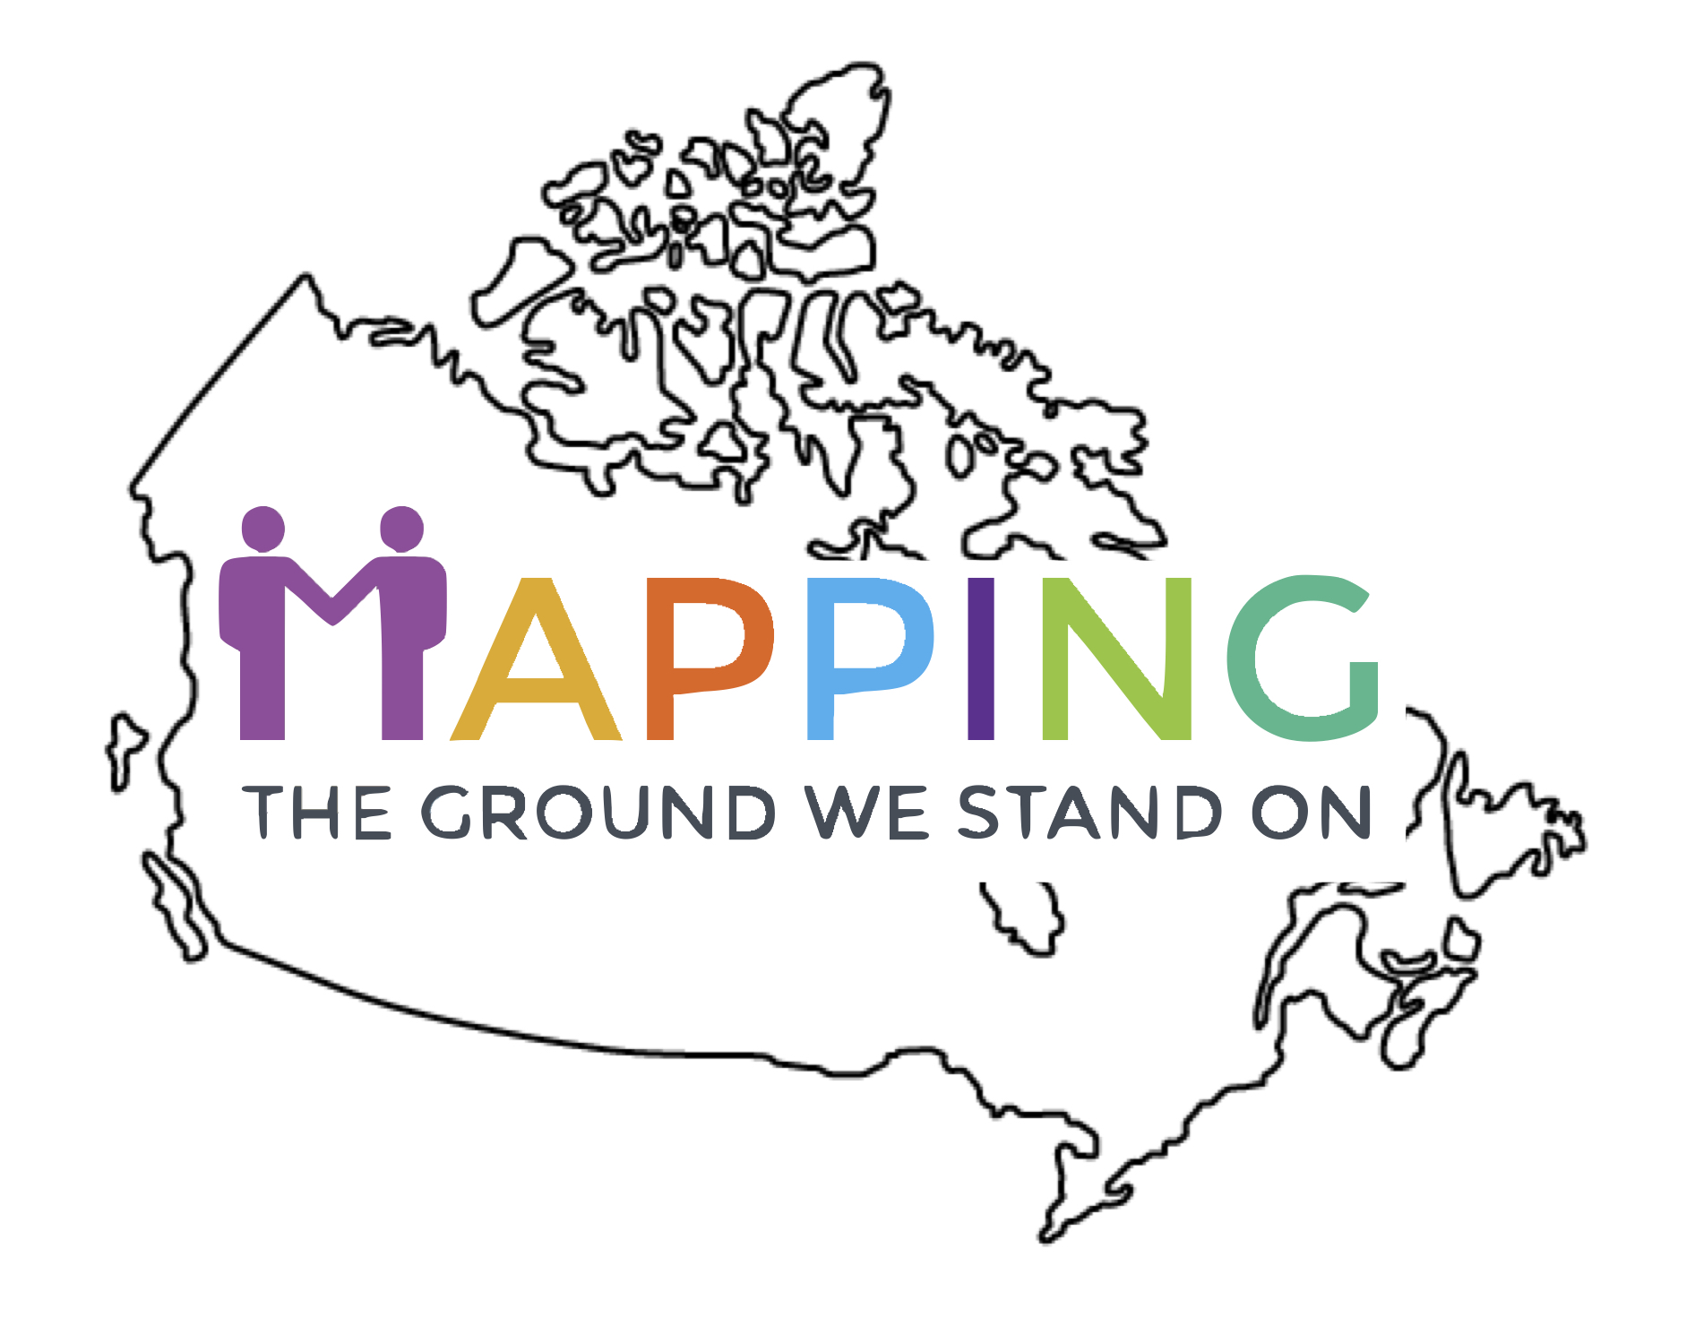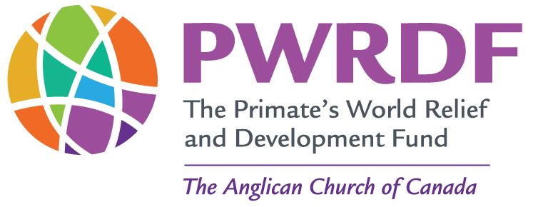

**MAPPING THE GROUND WE STAND ON WORSHOP**

**Registration Form**

Name: ____________________________________________________________

Email Address: _____________________________________________________

Phone Number ____________________________________________________

Dietary Issues or Mobility/Access issues that we should be aware of:

___________________________________________________________________

Please send this form or an email with this information to:

Centennial Albert United Church (CAUC) – email: [cent.albert.uc@gmail.com](mailto:cent.albert.uc@gmail.com)

Mailing address: 19 Rosehill Blvd., Oshawa, ON., L1J 5G5

For more Information, please email CAUC or call 905725-8621