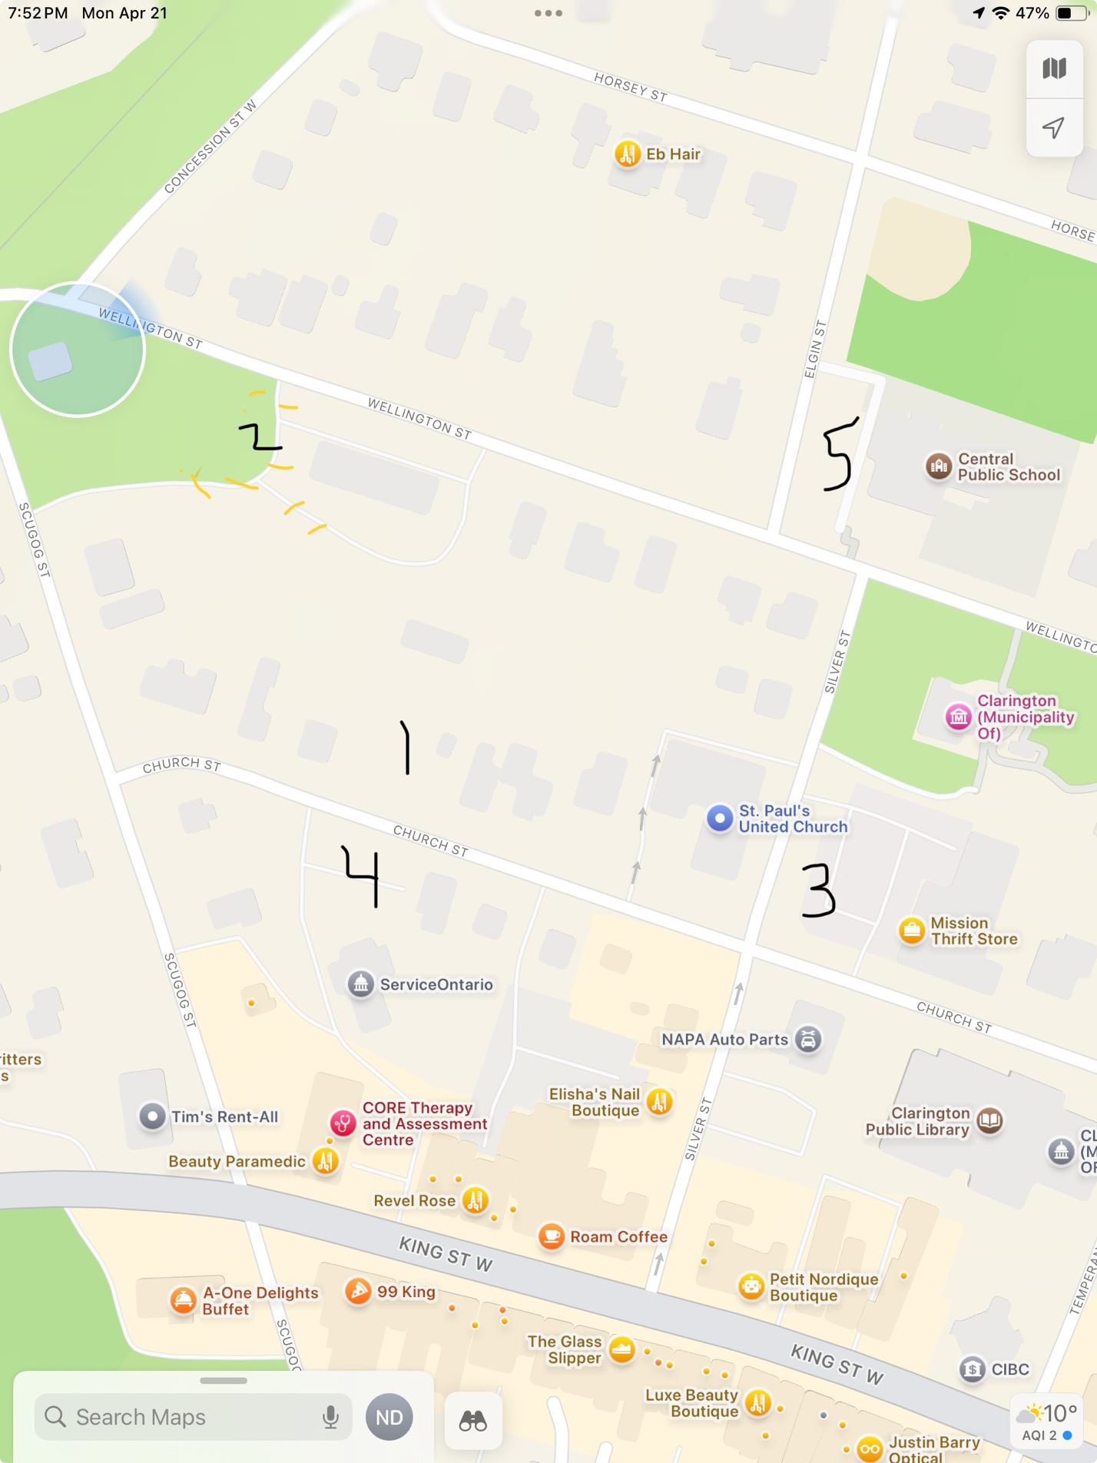

Parking for East Central Ontario Conference – May 23rd, May 24th, 2025 – St. Paul’s UC/St. Andrew’s PC Bowmanville

Lot 1 – is off of Church Street – it is 194/196 Church Street – park perpendicular to the fence/hedge – place “ Rice & Co parking pass” on the dash

Lot 2 is off Wellington Street, park to the west of the big red building. Angle park, on the grass as per signage stating: (yellow high lights) UCC Parking, - place “ Rice & Co. parking pass” on the dash

Lot 3 – is a municipal lot across from the church at the corner of Church and Silver Street

Lot 4 – is a municipal lot on Church Street

Lot 5 – is a school parking lot ONLY available on Friday night and Saturday.

There is on street parking in the neighbourhood on Wellington Street, Church Street and other side streets.

Authorized parking by  Rice & Co.  May 23/24, 2025  UCC Conference | Authorized parking by  Rice & Co.  May 23/24, 2025  UCC Conference
Authorized parking by  Rice & Co.  May 23/24, 2025  UCC Conference | Authorized parking by  Rice & Co.  May 23/24, 2025  UCC Conference

